 | Mitosis | Meiosis
Number of phases
Purpose
Number of chromosomes
Number of daughter cells
Other

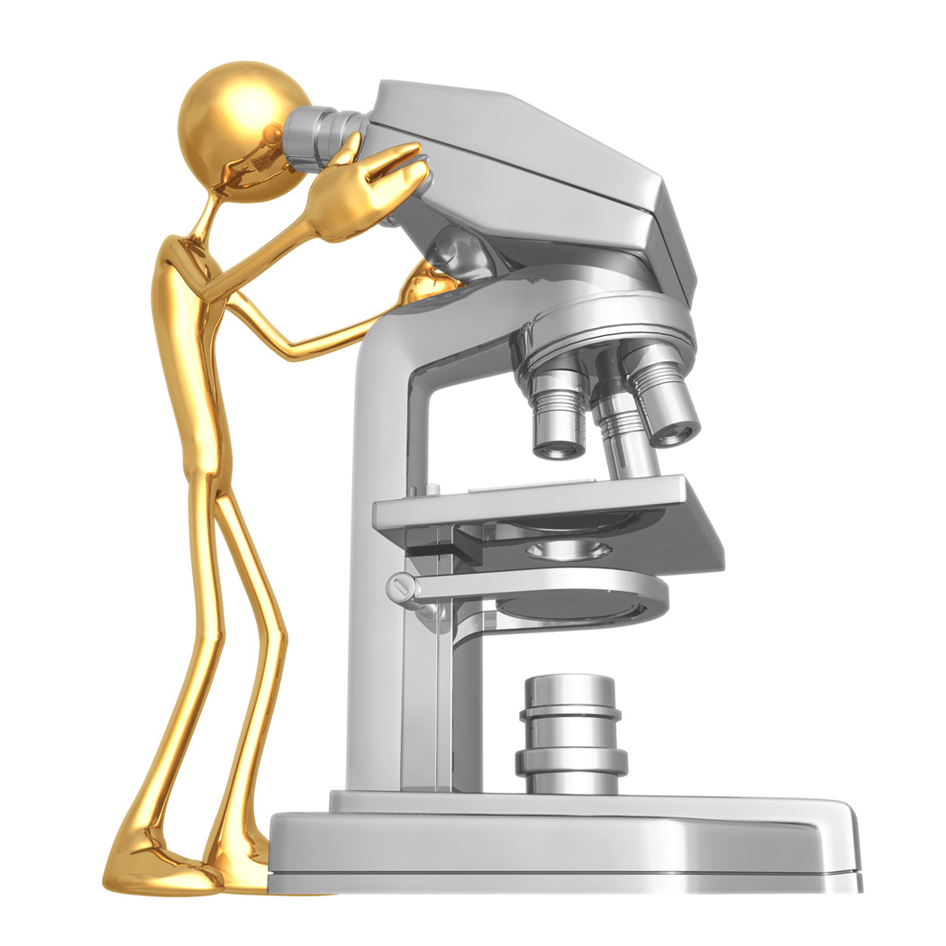
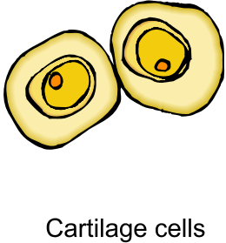
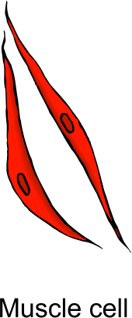
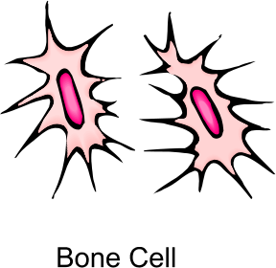
Mitosis and Meiosis

